1. Write a SQL statement that displays all the information about all salespeople.
2. Write a SQL statement to display specific columns such as names and commissions for all salespeople.

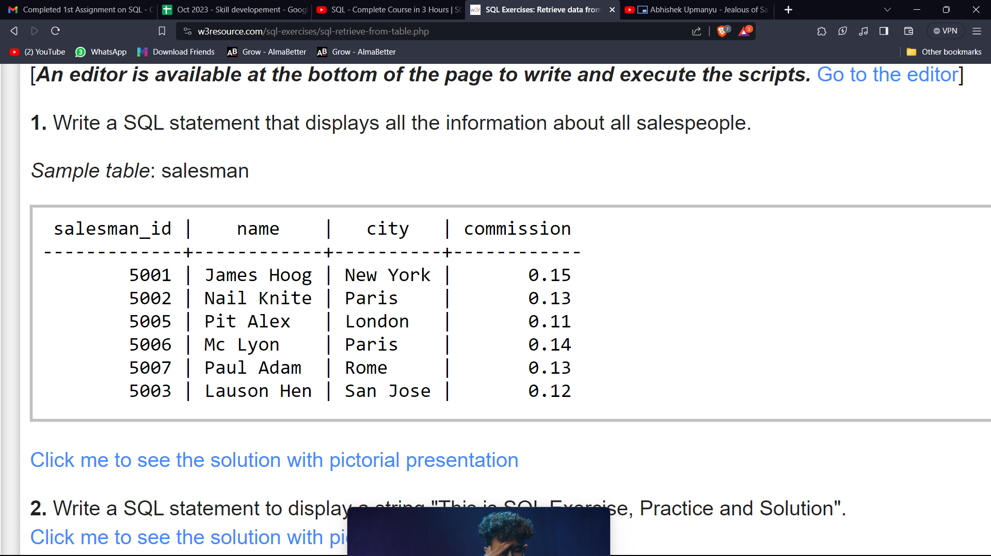

1. Write a query to display the columns in a specific order, such as order date, salesman ID, order number, and purchase amount for all orders.

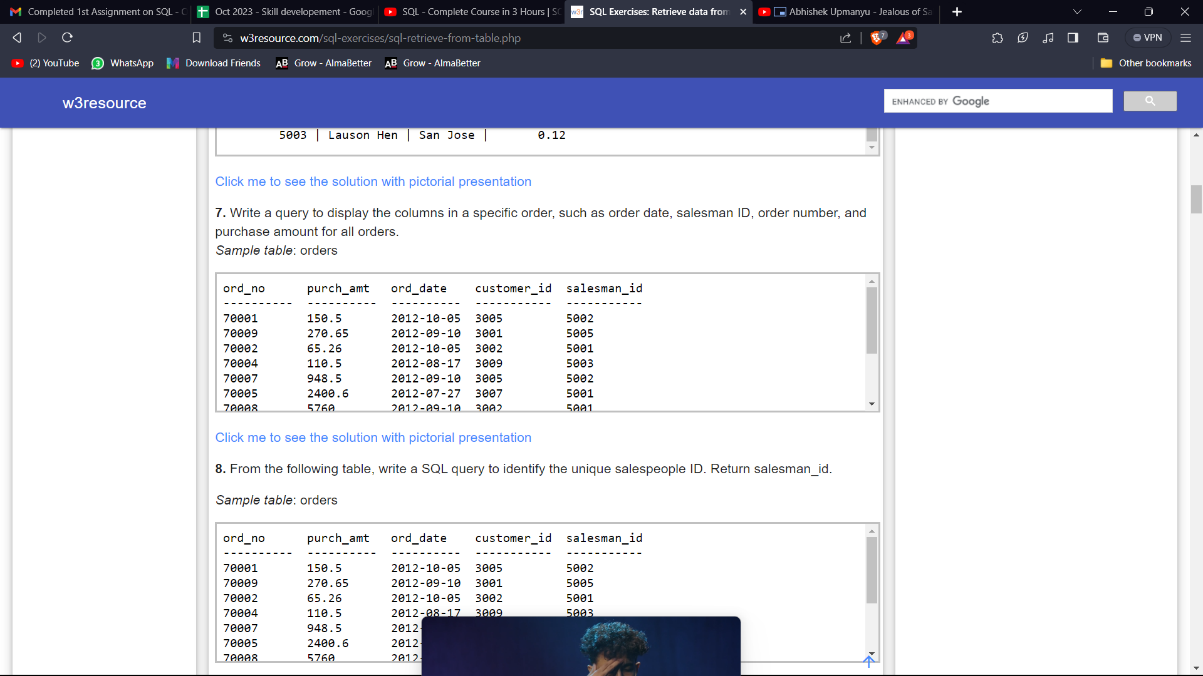

1. From the following table, write a SQL query to identify the unique salespeople ID. Return salesman_id.
2. From the following table, write a SQL query to locate salespeople who live in the city of 'Paris'. Return salesperson's name, city.



1. From the following table, write a SQL query to find customers whose grade is 200. Return customer_id, cust_name, city, grade, salesman_id.

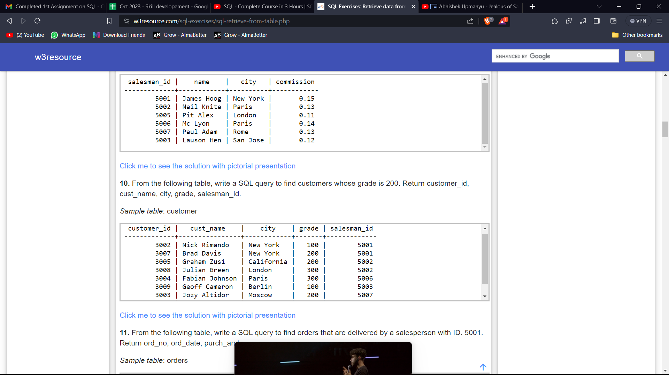

1. From the following table, write a SQL query to find orders that are delivered by a salesperson with ID. 5001. Return ord_no, ord_date, purch_amt.

